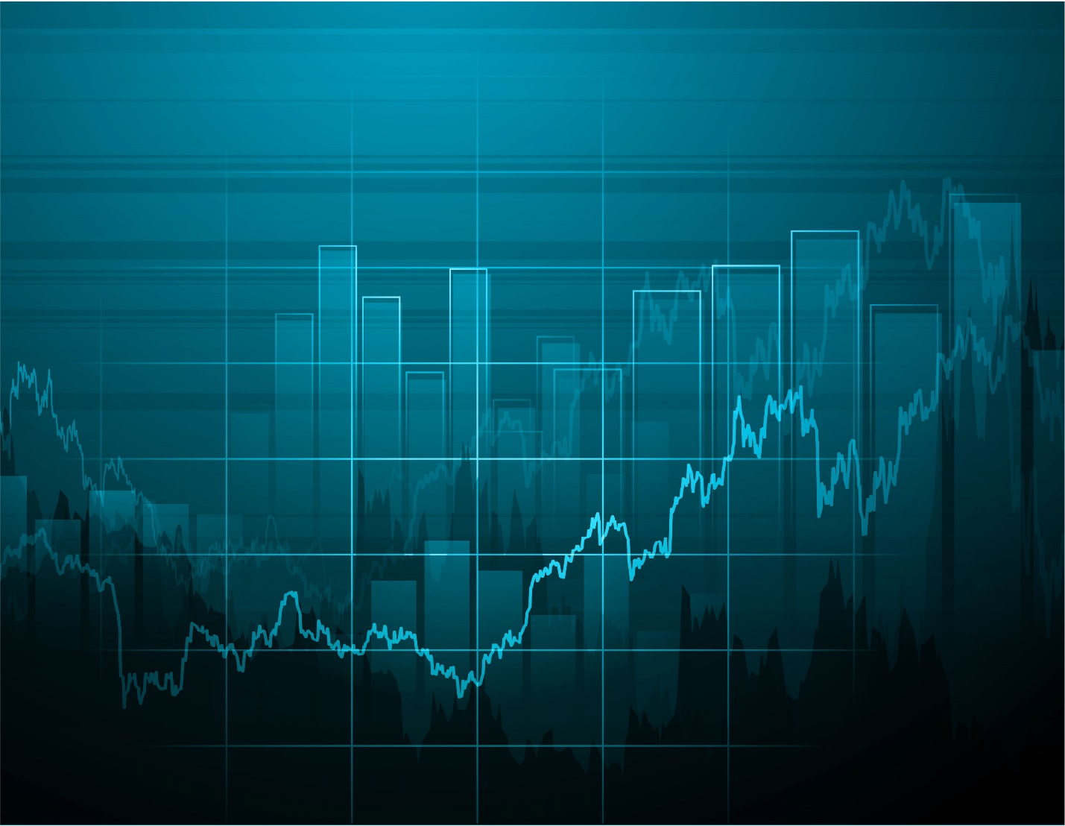

**Graphic Calculator**

K.N.SIVARAMAKRISHNAN

120235

**Bonafide**

**ACKNOWLEDGEMENT**

The aim of this program is to plot the graph of a function taken in from the user.

**CASE STUDY**

The user is allowed to enter an explicit function in x which can be trigonometric, polynomial or logarithmic in nature and the corresponding graph of the function will be plotted on the screen.

While viewing the graph of the function, the user can perform the following alterations to the graph-

* Zoom – The user can zoom in and out of the graph and the scale of the axes will be adjusted accordingly.
* Resolution – The user can choose from 3 different resolutions. This will increase or decrease the pixel density of the graph plotted based on the user’s choice.
* Color – The user can change the color of the curve being plotted from the given palette.

The user can also perform the following functions related to the equation read in-

* Store – The current equation gets stored in a text file.
* List – The user can choose to view any of the previously stored equations.
* Delete – The user can delete an equation stored in the list.

For void reverse(char s[])

Start

Read in string S[ ]

j=0

j<strlen(S)/2

char s=s[j]

s[j]=s[strlen(s)-j-1]

s[strlen(s)-j-1]=ch

j++

Stop

**FLOWCHART**

**LIMITATIONS**

* This program can only plot the graph of explicit functions of x, i.e., functions such as “y^2 = 2x + 3y”, “y ^2 = x^2 + xy + 3”, etc. cannot be used.
* Thus, parabolas, ellipses and circles can have their vertices or centers shifted only along the x- axis.
* This program cannot calculate polynomial functions with terms having fractional degrees or degrees greater than 4.
* Multiplication and division of two functions is not possible.

**SCOPE FOR IMPROVEMENT**

* Inclusion of brackets will help the user write equations in a more compact form. This has not been included in the program.
* A function to calculate the domain and range of the function could be included.
* More functions such as the Exponential function, Greatest Integer Function (G.I.F.), Modulus function etc. can be included.
* Parametric functions could also be made a part of this program, i.e., the variables need not be in terms of “x” and “y” only. eg. y = tan(t).

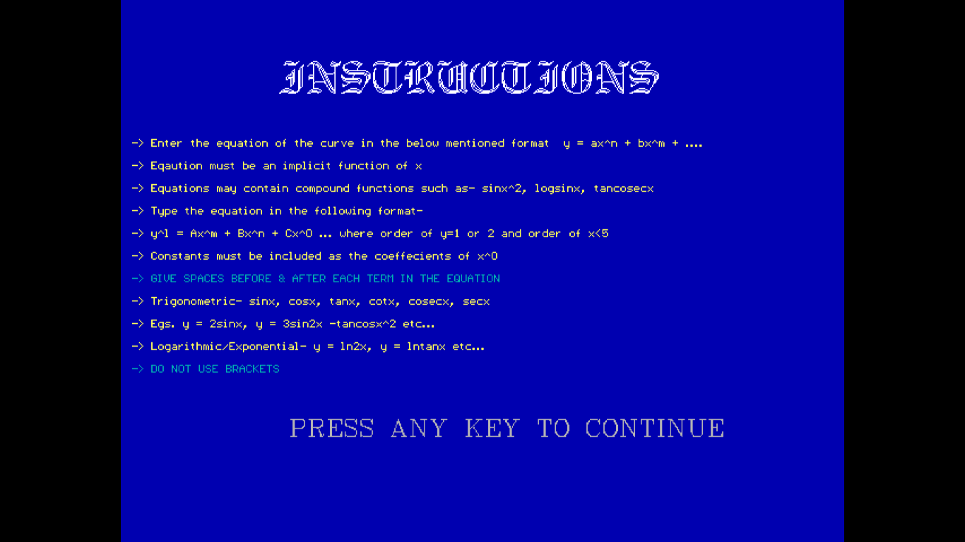

Instructions Page

Menu Screen

**SCREENSHOTS**

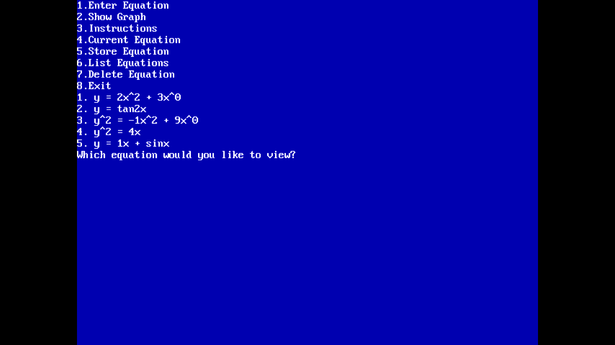

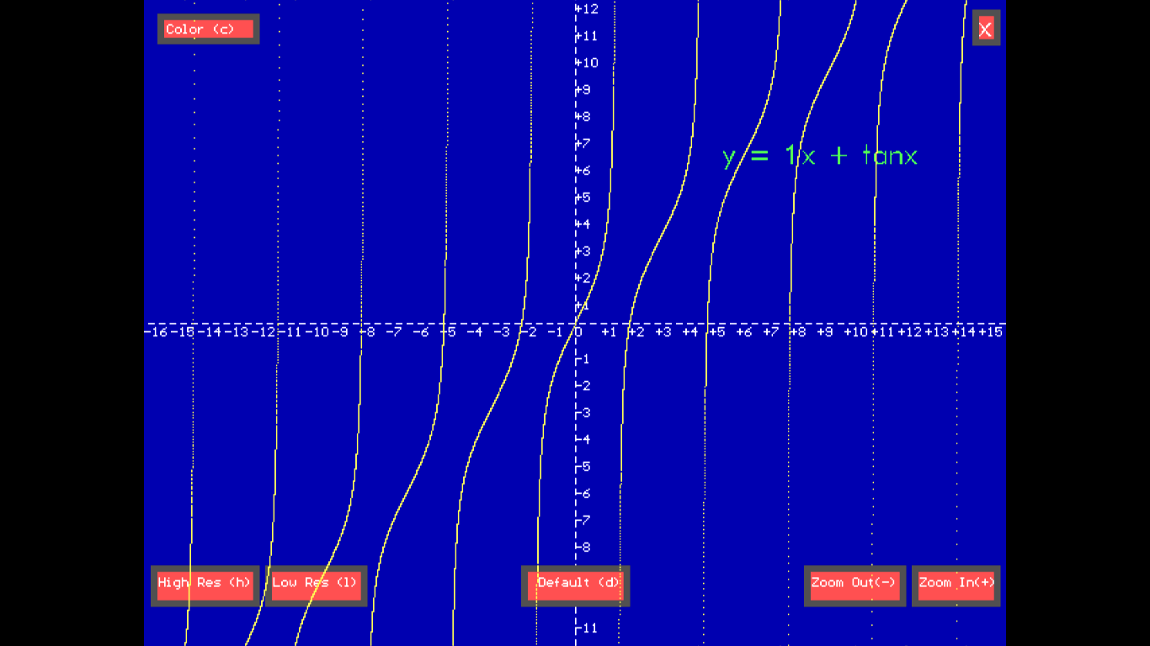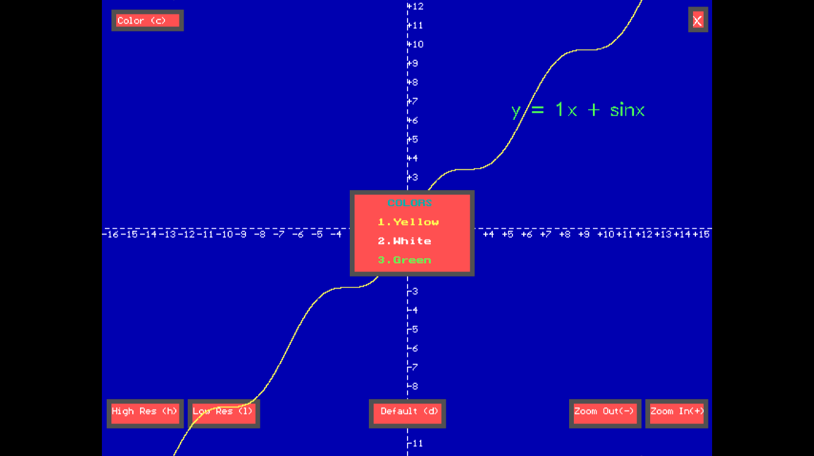

y = x + tanx

y = x + sinx (along with on screen menu)

**SAMPLE GRAPHS**

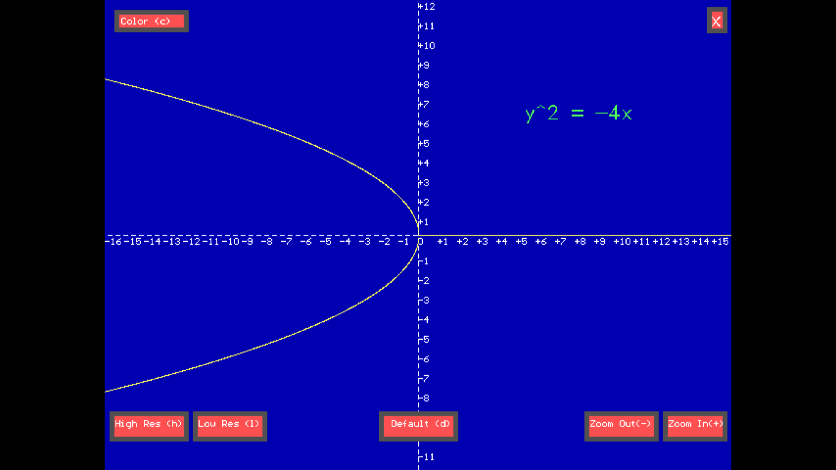

y^2 = -4x (Parabola with focus at [-1,0])

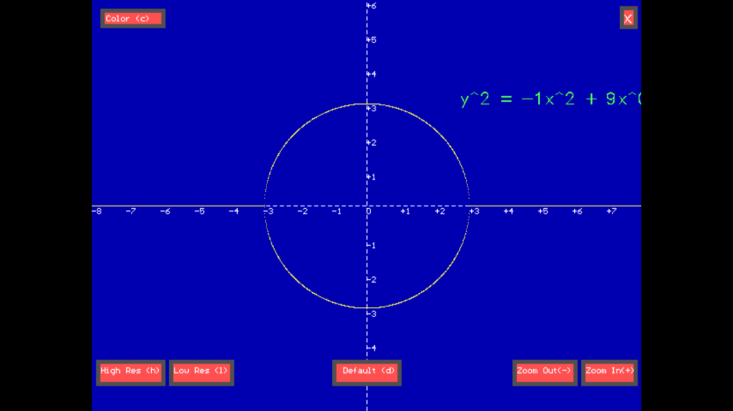

y^2 = -1x^2 + 9 (Circle with radius 3)

#include<fstream.h>

**PROGRAM CODE**

#include<dos.h>

#include<ctype.h>

#include<stdio.h>

#include<conio.h>

#include<string.h>

#include<stdlib.h>

#include<math.h>

#include<graphics.h>

float ld=-20,ud=20;

int pwry=1,var=1;

const float pi=22/7;

void reverse(char s[]) //reverses string

{for(int j=0;j<(strlen(s)/2);j++)

{char ch=s[j];

s[j]=s[strlen(s)-j-1];

s[strlen(s)-j-1]=ch;

}}

float strtoint(char a[]) //converts char to float

{float n=0,i=0,dec=0,ct1=0;

for(i=0;a[i]!='\0';i++)

if(a[i]=='.')

ct1++;

if(ct1==1)

{for(i=0;a[i]!='\0';i++)

if(a[i]=='.')

dec=i;

for(i=0;i<dec;i++)

n+=(a[i]-48)*pow(10,dec-i-1);

for(i=dec+1;i<strlen(a);i++)

n+=(a[i]-48)*(1/pow(10,i-dec));

}

else

for(i=0;a[i]!='\0';i++)

n+=(a[i]-48)*pow(10,strlen(a)-i-1);

return n;

}

void put(int color=14) //To insert pixel at current location

{int x=getx();

int y=gety();

putpixel(x,y,color);}

double rety(char a[],float x) //returns y for fn of x

{

double term,exp=0;

int pwrx=1;

float coeff=1;

for(int i=0;i<strlen(a);i++)

{

if(a[i]==' ')

i++;

else if(tolower(a[i])=='y'&&a[i+1]=='^')

pwry=a[i+2]-48;

else if(tolower(a[i])=='x')

{

int ct=0;

if(a[i+1]=='^')

{pwrx=a[i+2]-48;

if(pwrx>5)

break;}

for(int h=i-1;a[h]!=' ';h--)

{

if(a[h]=='-')

{

term=-term;

ct++;

}

else if(isdigit(a[h]))

//to retrieve coefficient

{

char buff[20];

for(int j=h,k=0;isdigit(a[j])||a[j]=='.';j--,k++)

buff[k]=a[j];

buff[k]='\0';

reverse(buff);

coeff=strtoint(buff);

if(ct==0)

term=coeff*pow(x,pwrx);

else

term=coeff*pow(term,pwrx);

ct++;

}

else if(isalpha(a[h])) //functions

{

char s[10];

for(int g=h,k=0;isalpha(a[g]);g--,k++)

s[k]=a[g];

s[k]='\0';

reverse(s);

if(ct==0)

term=pow(x,pwrx);

if(strcmpi(s,"sin")==0)

{term=sin(term);

}

else if(strcmpi(s,"tan")==0)

term=tan(term);

else if(strcmpi(s,"cos")==0)

{term=cos(term);

}

else if(strcmpi(s,"cot")==0)

term=1/tan(term);

else if(strcmpi(s,"cosec")==0)

term=1/sin(term);

else if(strcmpi(s,"log")==0)

{if(term<0)

term=0;

else

term=log10(fabs(term));

var*=2;}

else if(strcmpi(s,"ln")==0)

{if(term<0)

term=0;

term=log(fabs(term));

::var*=2;}

else if(strcmpi(s,"asin")==0)

{term=asin(term);

::var*=3;}

else if(strcmpi(s,"atan")==0)

term=atan(term);

else if(strcmpi(s,"acos")==0)

{term=acos(term);

::var*=3;}

ct++;

}

}

if(ct==0)

term=pow(x,pwrx);

exp+=term;

}

}

double ret;

if(exp<0&&pwry%2==0)

ret=0;

else

ret=pow(exp,1.0/pwry);

return ret;

}

void instructions()

{

int gd=DETECT,gm;

initgraph(&gd,&gm,"C:/TC/BGI");

clearviewport();

setbkcolor(BLUE);

settextstyle(GOTHIC_FONT,0,5);

outtextxy(100,40,"INSTRUCTIONS");

settextstyle(2,0,4);

setcolor(YELLOW);

outtextxy(10,120,"-> Enter the equation of the curve in the below mentioned format\n y = ax^n + bx^m + ....");

delay(500);

outtextxy(10,140,"-> Eqaution must be an implicit function of x ");

delay(500);

outtextxy(10,160,"-> Equations may contain compound functions such as- sinx^2, logsinx, tancosecx");

delay(500);

outtextxy(10,180,"-> Type the equation in the following format-");

delay(500);

outtextxy(10,200,"-> y^l = Ax^m + Bx^n + Cx^0 ... where order of y=1 or 2 and order of x<5");

delay(500);

outtextxy(10,220,"-> Constants must be included as the coeffecients of x^0 ");

delay(500);

setcolor(CYAN);

outtextxy(10,240,"-> GIVE SPACES BEFORE & AFTER EACH TERM IN THE EQUATION");

delay(500);

setcolor(YELLOW);

outtextxy(10,260,"-> Trigonometric- sinx, cosx, tanx, cotx, cosecx, secx");

delay(500);

outtextxy(10,280,"-> Egs. y = 2sinx, y = 3sin2x -tancosx^2 etc...");

delay(500);

outtextxy(10,300,"-> Logarithmic/Exponential- y = ln2x, y = lntanx etc...");

delay(500);

setcolor(CYAN);

outtextxy(10,320,"-> DO NOT USE BRACKETS");

delay(500);

settextstyle(8,0,3);

setcolor(135);

outtextxy(150,360,"PRESS ANY KEY TO CONTINUE");

getch();

clearviewport();

}

/*To draw co-ordinate axes of unit n(multiple of 8)

x - scale

n - division of screen*/

void axes(int x)

{setlinestyle(3,1,1);

setcolor(WHITE);

settextstyle(2,0,0);

int n=-320/x;

for(int i=-320;i<=320;i+=x,n++) //incrementing by scale

{char s[5];

if(n<0)

s[0]='-';

else if(n>0)

s[0]='+';

else s[0]='0';

for(int f=n,j=1;f!=0;f/=10,j++) //retrieving first digit

s[j]=abs(f)%10+48;

s[j]='\0';

for(j=1;j<strlen(s)/2+1;j++) //retrieving second digit

{char ch=s[j];

s[j]=s[strlen(s)-j];

s[strlen(s)-j]=ch;

}

outtextxy(i+320,240,s);

outtextxy(320,-i+240,s);

}

line(320,0,320,480);

line(0,240,640,240);

}

/*TEXT FILE FUNCTIONS

FILE NAME: strings.txt*/

void store(char s[])

{

fstream f("strings.txt",ios::in|ios::app);

if(!f)

{cout<<"error";

return;

}

f<<s<<endl;

f.close();

}

void list()

{

ifstream f("strings.txt",ios::in);

if(!f)

{cout<<"Error";

return;

}

char s[30];

int ct=1;

while(f.getline(s,30,'\n'))

{cout<<ct++<<". "<<s<<endl;

}

f.close();

}

void clear()

{ofstream f("strings.txt");

f.close();}

void select(int n, char a[])

{

ifstream f("strings.txt",ios::in);

if(!f)

{cout<<"Error";

return;

}

char s[30];

int ct=1;

while(f.getline(s,30,'\n'))

{if(ct++==n)

strcpy(a,s);

}

f.close();

}

void del(int n)

{ifstream f("strings.txt");

ofstream g("temp.txt",ios::out);

if(!f||!g)

{cout<<"Error";

return;}

char ch[30];

int ct=1;

while(f.getline(ch,30,'\n'))

{if(ct==n);

else

g<<ch<<endl;

ct++;}

f.close();

g.close();

remove("strings.txt");

rename("temp.txt","strings.txt");

}

void menu()

{

setfillstyle(1,DARKGRAY);

bar(570,420,635,450);

setfillstyle(1,LIGHTRED);

bar(575,425,630,445);

setcolor(WHITE);

outtextxy(576,426,"Zoom In(+)");

setfillstyle(1,DARKGRAY);

bar(490,420,565,450);

setfillstyle(1,LIGHTRED);

bar(495,425,560,445);

setcolor(WHITE);

outtextxy(496,426,"Zoom Out(-)");

setfillstyle(1,DARKGRAY);

bar(5,420,85,450);

setfillstyle(1,LIGHTRED);

bar(10,425,80,445);

setcolor(WHITE);

outtextxy(11,426,"High Res (h)");

setfillstyle(1,DARKGRAY);

bar(90,420,165,450);

setfillstyle(1,LIGHTRED);

bar(95,425,160,445);

setcolor(WHITE);

outtextxy(96,426,"Low Res (l)");

setfillstyle(1,DARKGRAY);

bar(10,10,85,32);

setfillstyle(1,LIGHTRED);

bar(15,15,80,27);

setcolor(WHITE);

outtextxy(17,15,"Color (c)");

setfillstyle(1,DARKGRAY);

bar(280,420,360,450);

setfillstyle(1,LIGHTRED);

bar(285,425,355,445);

setcolor(WHITE);

outtextxy(293,426,"Default (d)");

setfillstyle(1,DARKGRAY);

bar(615,7,635,33);

setfillstyle(1,LIGHTRED);

bar(620,12,630,28);

setcolor(WHITE);

settextstyle(3,0,2);

outtextxy(620,5,"x");

}

void main()

{clrscr();

char s[50]="NULL";

int color=14;

float scale=20,ch,pd=0.01;

int gd=DETECT,gm;

initgraph(&gd,&gm,"C:/TC/BGI");

settextstyle(1,0,6);

setbkcolor(BLUE);

setcolor(LIGHTGRAY);

bar(0,0,30,480);

bar(0,0,640,30);

bar(610,0,640,480);

bar(0,450,640,480);

outtextxy(50,100,"GRAPHIC CALCULATOR");

settextstyle(SANS_SERIF_FONT,0,2);

outtextxy(175,280,"Press Any Key To Continue");

getch();

//instructions();

clearviewport();

do{::var=1;

clrscr();

clearviewport();

setbkcolor(BLUE);

cout<<"1.Enter Equation \n";

cout<<"2.Show Graph\n3.Instructions\n4.Current Equation\n5.Store Equation\n6.List Equations\n7.Delete Equation\n8.Exit\n";

ch=getch()-48;

if(ch==1)

gets(s);

else if(ch==3)

{instructions();}

else if(ch==4)

{cout<<endl<<s<<endl;

getch();}

else if(ch==5)

{store(s);

cout<<"Stored!\n"; }

else if(ch==6)

{list();

cout<<"Which equation would you like to view?";

int n=getch()-48;

select(n,s);}

else if(ch==7)

{list();

cout<<"Which equation must be deleted?";

int n=getch()-48;

del(n);

}

else if(ch==2)

{initgraph(&gd, &gm, "C:/TC/BGI");

Graph:

cleardevice();

pwry=1;

setbkcolor(BLUE);

setlinestyle(3,1,1);

axes(scale);

moveto(320,240);

menu();

if(var%2==0)

ld=0;

if(var%3==0)

{ld=-1;

ud=1;}

setcolor(LIGHTGREEN);

outtextxy(430,100,s);

for(float i=ld,k=0;i<=ud;i+=pd,k++)

{

float x=i*scale,y=-rety(s,i)*scale;

if(::pwry==2)

{

moverel(x,-y);

put(color);

moveto(320,240);

moverel(x,y);

put(color);}

else {moveto(320,240);

moverel(x,y);

put(color);

}

moveto(320,240);

}

char c='\0';

while(c!='e')

{

c=getch();

if(c=='x'||c=='X'||c==27)

{setfillstyle(1,DARKGRAY);

bar(260,225,380,255);

setfillstyle(1,LIGHTRED);

bar(265,230,375,250);

setcolor(LIGHTGREEN);

outtextxy(265,227,"Exit? (y/n)");

char o=getch();

if(o=='y'||o=='Y')

c='e';

else goto Graph;

}

else if(c=='c'||c=='C')

{setfillstyle(1,DARKGRAY);

bar(260,200,390,290);

setfillstyle(1,LIGHTRED);

bar(265,205,385,285);

settextstyle(0,0,0);

setcolor(CYAN);

outtextxy(300,210,"COLORS");

setcolor(YELLOW);

outtextxy(290,230,"1.Yellow");

setcolor(WHITE);

outtextxy(290,250,"2.White");

setcolor(LIGHTGREEN);

outtextxy(290,270,"3.Green");

int f=getch()-48;

if(f==1)

color=14;

else if(f==2)

color=15;

else if(f==3)

color=10;

goto Graph;

}

else if(c=='+')

{scale+=10;

goto Graph;}

else if(c=='-')

{scale-=5;

goto Graph;}

else if(c=='h'||c=='H')

{pd=pow(0.1,3);

goto Graph;}

else if(c=='l'||c=='L')

{pd=pow(0.1,1);

goto Graph;}

else if(c=='d'||c=='D')

{pd=pow(0.1,2);

scale=20;

goto Graph;}

else

{setfillstyle(1,DARKGRAY);

bar(215,225,420,255);

setfillstyle(1,LIGHTRED);

bar(220,230,415,250);

setcolor(LIGHTGREEN);

outtextxy(225,227,"INVALID CHARACTER");

getch();

gotoxy(280,220);

goto Graph;}}

}

}while(ch!=8);

getch();

}

**BIBLIOGRAPHY**